Advanced Channeling Technologies:
Strong External Electromagnetic Fields to Guide Charged & Neutral Beams
Sultan B. Dabagov
INFN Laboratori Nazionali di Frascati, 00044 Frascati (RM), Italy

Thursday 15thNovember 2018 at 4:00 pm, Fisher Room,
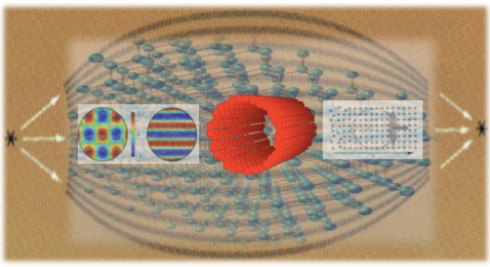
Denys Wilkinson Building, Keble Rd, Oxford

Channeling is the phenomenon well-known in the physics world mostly related to the propagation of the beams of charged particles in aligned crystals. Since the beginning of 1970s channeling of high-energy leptons (electrons/positrons of several MeV up to hundred of GeV energies) and hadrons (protons/ions of tens GeV up to several TeV energies) has been applied at various famous world research centres within different national/international projects related to the phenomenon utilization to shape the beams as well as to produce high power x-ray and gamma radiation sources.
However, recent studies have shown the feasibility of channeling phenomenology application for description of other various mechanisms of interaction of charged as well as neutral particles beams in solids, plasmas and electromagnetic fields covering the research fields from crystal/laser/plasma based undulators and collimators to capillary based x-ray and neutron optical elements.
This review talk is devoted to actual channeling-based projects that have been realizing since so-called renessiance of channeling studies started in the end of last century. The future possible developments in channeling physics will be analyzed within the presentation.
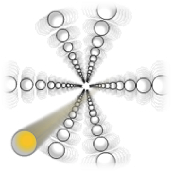

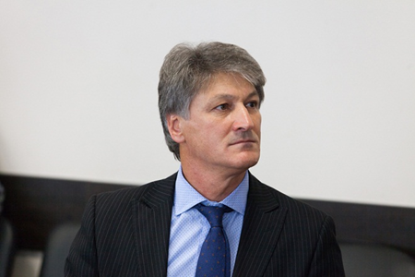

Professor Sultan Dabagov is the Director of the laboratory “XLab Frascati” of the National Laboratory of Frascati of the National Institute for Nuclear Physics. He is graduated from P.N. Lebedev Physical Institute, Lab. High Energy Electrons with Doctor of Sciences in Physics & Mathematics degree in 1996 and in 1998 he has joined INFN Laboratori Nazionali di Frascati (Frascati-Roma, Italy) and in 2012 he become the Director of the laboratory “XLab Frascati” INFN.

